social media in business

Oliver Collins-Cope

Richmond Upon Thames College

BTEC National Foundation Diploma IT

Table of Contents

Introduction 2

Different Social Media Sites 2

Facebook 2

Audience profile of Facebook 2

Bibliography 3

# Introduction

The use and influence of business in social media is growing larger by the day, with more businesses investing in starting Social Media pages on different websites and applications, as the potential for growth and exposure comes at just the click of a button to post. With more people using social media applications and websites, with an estimated 3.78 billion users in 2021 (Statista Research Department, 2022), it is crucial for businesses to have an online presence, not only to advertise to customers, but in order to be au-fait with the current era and be able to provide a modern experience for the customer base, as well as provide adequate support where required using different features such as private messages, comment sections, and many more.

# Different Social Media Sites

## Facebook

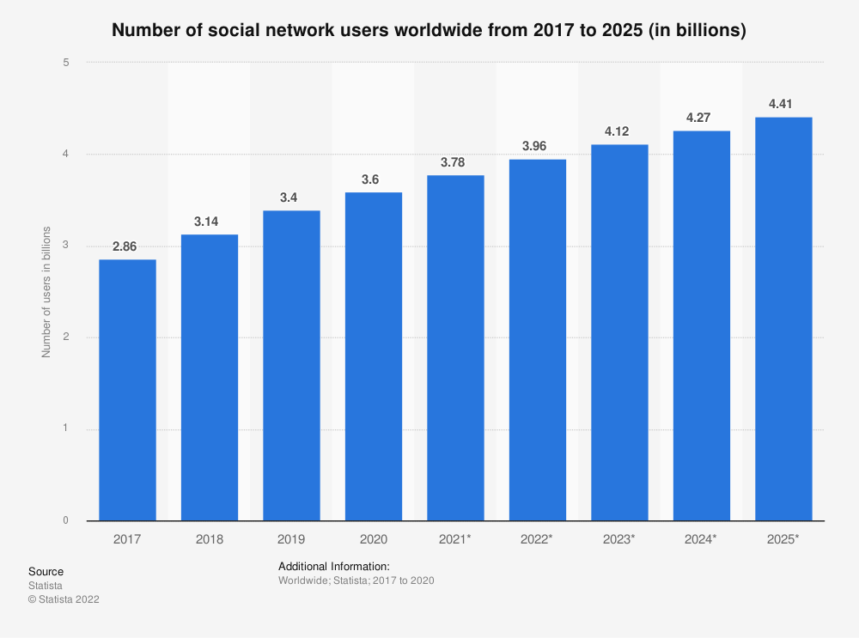Arguably the most famous and biggest social media giant out there, Facebook remains at the forefront of social media since it was founded in 2004. With around 2.9 billion active users in 2021 (DataReportal, 2021) (Iqbal, 2022) Facebook remains to be the largest social media site in use, beating YouTube in second place by around 600 million active users in 2021 (Statista Research Department, 2022) proving Facebooks status as a necessity for any business to grow and expand.

(Statista Research Department, 2022)

### Audience profile of Facebook

The largest demographic group of Facebook users is between around 25-35 years of age (Aslam, 2022). Around 56% of Facebooks user base is male, with the remaining 44% identifying as female, as Facebook does not allow users to select nonbinary gender types (Aslam, 2022).

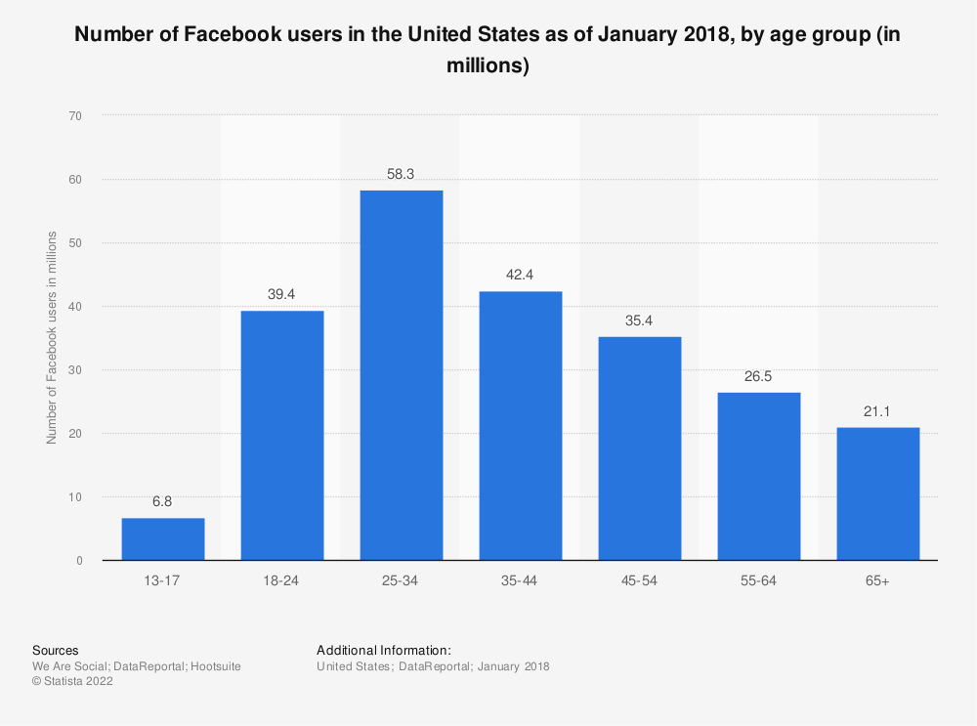

(Statista Research Department, 2022)

Within the largest age demographic of 25-35 years of age, 19% of all active male users are within this age group, and 12.5% of all females are within this age group, which are the highest percentage of any given gender in any age group, and makes up the majority of users as of October 2021 (Statista Research Department, 2022).

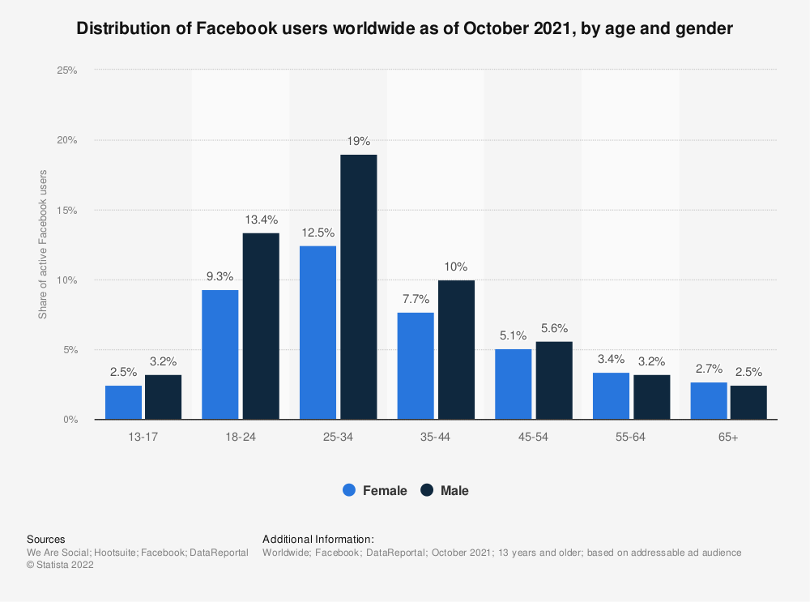  
The next largest demographic of Facebook would be the 18-24 range. Males in this age group make up roughly 13% of all Facebook users, while females make up around 9% of Facebook users (Statista Research Department, 2022).

### Facebook and Business

There are a number of features available to businesses on Facebook, which are not limited to just those available to a standard user. The primary features Facebook has to offer to businesses comes from the “Facebook Page” feature, which allows a user, or business in this scenario, to create a page for a specific thing, such as the business in question, and post on behalf of the business. In addition to adding a presence on the website, it also allows users to discover the business just through searching through a search engine and finding a social media for it on business, or searching through Facebook and discovering through that.

The features included with “Facebook Page” includes:

* Calls-to-Action
* Post Scheduling
* Profanity Filters
* Page Moderation
* Free page suggestions to users
* Scheduling events
* Pages to watch/Up to date comparison
* When your page users are most active
* Statistics for post types
* Seeing how competitors are performing
* Exporting page insights
* Target audience selection
* Creating Adverts
* Multiple Adverts at a single time for specific audiences
* Page Customisation (Aesthetic)

(Urrutia, 2015) (Howen, 2015)

# Bibliography

Aslam, S., 2022. *Omnicore.* [Online]   
Available at: https://www.omnicoreagency.com/facebook-statistics/#:~:text=56%25%20of%20the%20total%20Facebook,to%20only%20male%20or%20female).&text=(Source%3A%20Statista)-,The%20largest%20demographic%20group%20of%20Facebook%20users%20is%20between%20the,of%20the%20popul  
[Accessed 1 February 2022].

DataReportal, 2021. *DataReportal.* [Online]   
Available at: https://datareportal.com/essential-facebook-stats  
[Accessed 1 February 2022].

DataReportal, 2022. *DataReportal.* [Online]   
Available at: https://datareportal.com/social-media-users  
[Accessed 1 February 2022].

Howen, A., 2015. *Website magazine.* [Online]   
Available at: https://www.websitemagazine.com/blog/10-facebook-business-page-features-you-should-be-using  
[Accessed 2 February 2022].

Iqbal, M., 2022. *BusinessOfApps.* [Online]   
Available at: https://www.businessofapps.com/data/facebook-statistics/  
[Accessed 1 February 2022].

Statista Research Department, 2022. *Statista.* [Online]   
Available at: https://www.statista.com/statistics/278414/number-of-worldwide-social-network-users/#:~:text=How%20many%20people%20use%20social,almost%204.41%20billion%20in%202025.  
[Accessed 1 February 2022].

Statista Research Department, 2022. *Statista.* [Online]   
Available at: https://www.statista.com/statistics/272014/global-social-networks-ranked-by-number-of-users/  
[Accessed 1 February 2022].

Statista Research Department, 2022. *Statista.* [Online]   
Available at: https://www.statista.com/statistics/398136/us-facebook-user-age-groups/  
[Accessed 1 February 2022].

Urrutia, K., 2015. *Single Grain.* [Online]   
Available at: https://www.singlegrain.com/facebook/12-important-facebook-features-every-marketer-needs-to-take-advantage-of/  
[Accessed 2 February 2022].